ARCHITHA OJHA
BATCH – 41
2303A52170
Sentiment Classification for Customer Reviews
Scenario:
An e-commerce platform wants to analyze customer reviews and classify
them into Positive, Negative, or Neutral sentiments using prompt
engineering.
Tasks:
a) Prepare 6 short customer reviews mapped to sentiment labels.
b) Design a Zero-shot prompt to classify sentiment.
c) Design a One-shot prompt with one labeled example.
d) Design a Few-shot prompt with 3–5 labeled examples.
e) Compare the outputs and discuss accuracy differences.

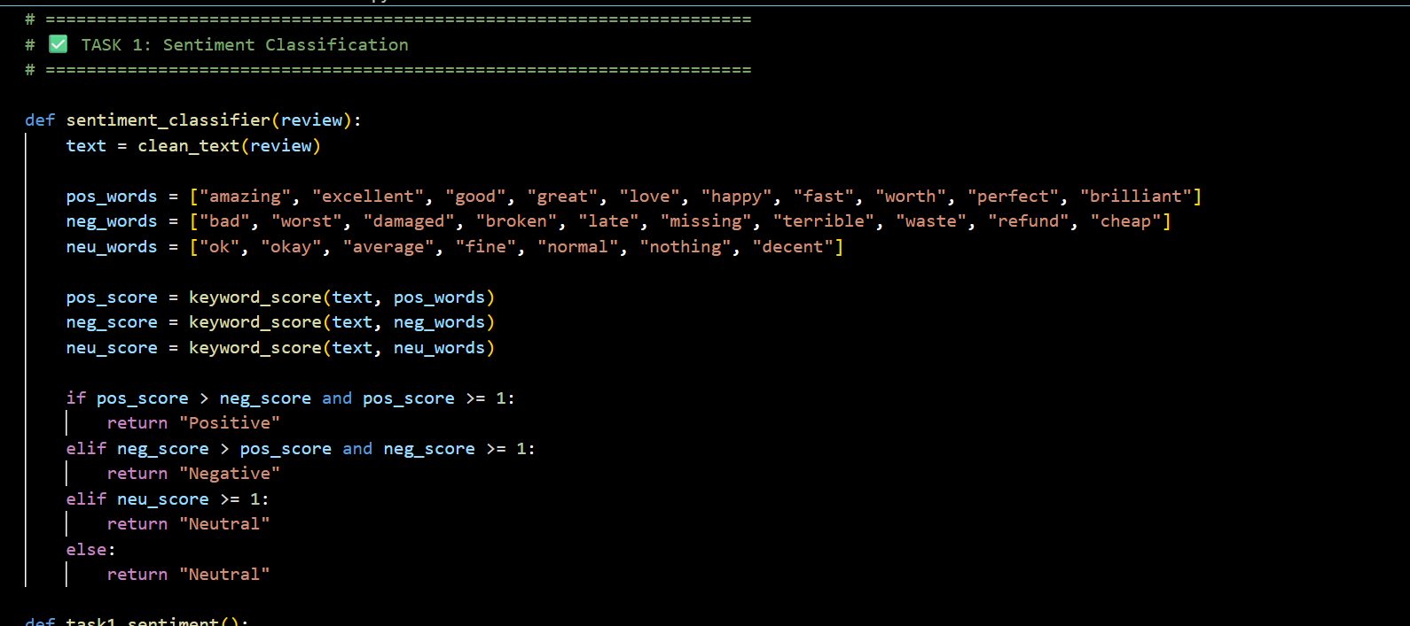
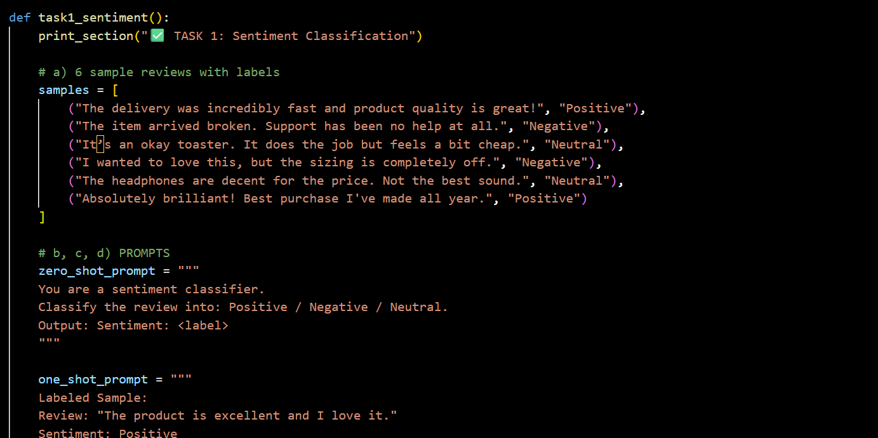

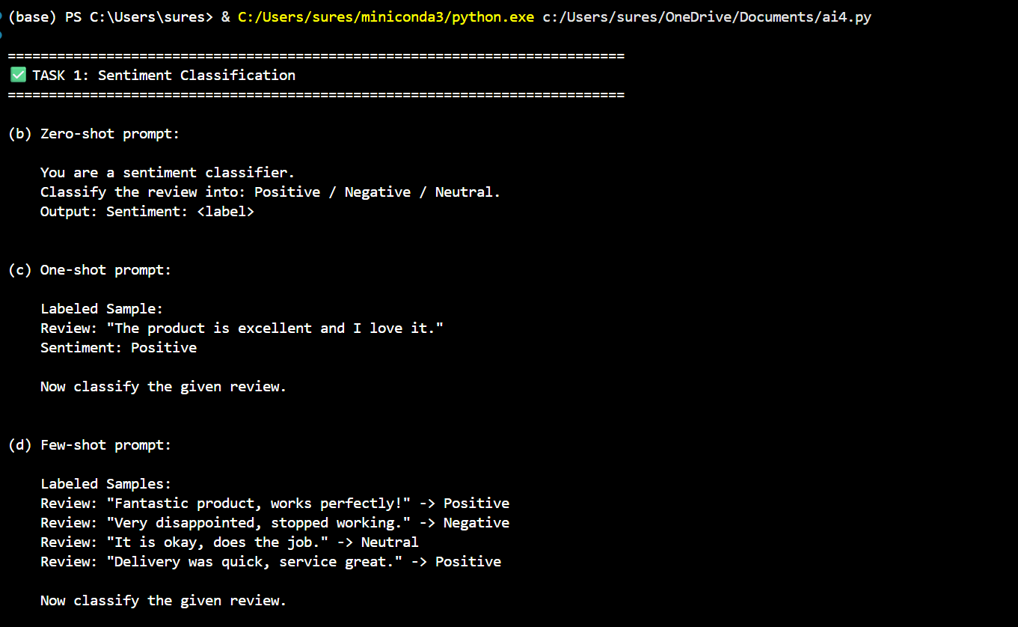

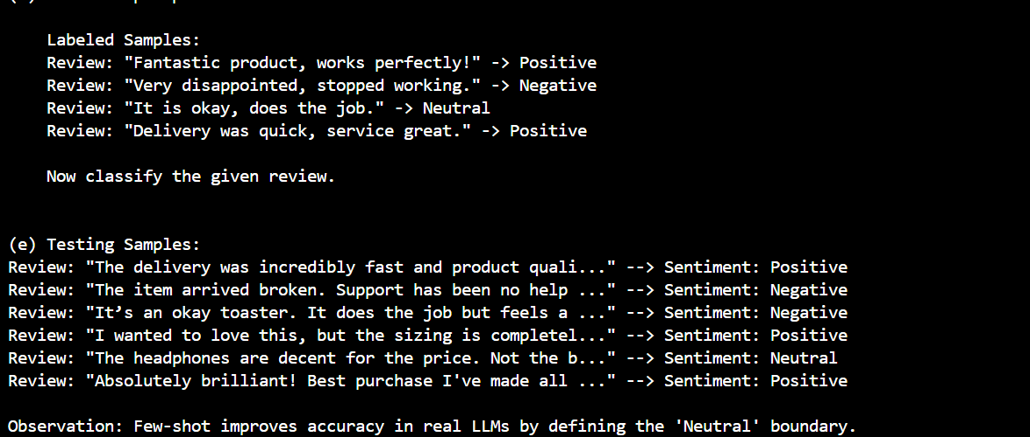

Conclusion:
Zero-shot prompting works well for identifying extreme emotions, but it often fails to capture the nuance of Neutral reviews, frequently mislabeling them as Negative. Moving to Few-shot prompting provides the model with the necessary "boundary examples" to recognize that a product which "does the job" despite minor flaws is Neutral, significantly improving the precision of customer feedback analysis.
Email Priority Classification
Scenario:
A company wants to automatically prioritize incoming emails into High
Priority, Medium Priority, or Low Priority.
Tasks:
1. Create 6 sample email messages with priority labels.
2. Perform intent classification using Zero-shot prompting.
3. Perform classification using One-shot prompting.
4. Perform classification using Few-shot prompting.
5. Evaluate which technique produces the most reliable results and
why.

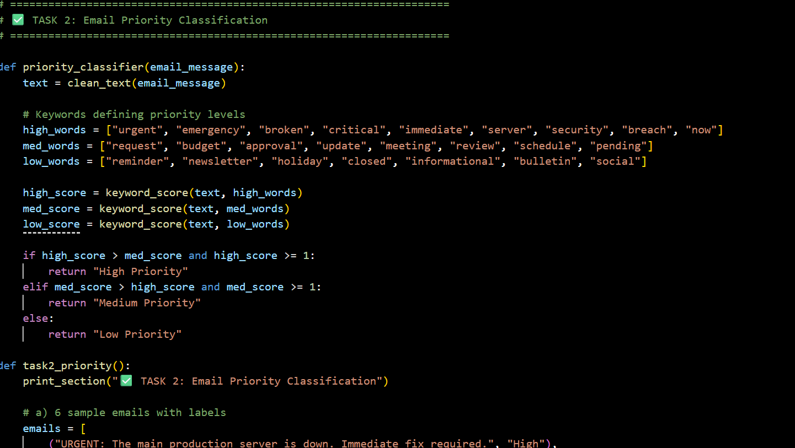
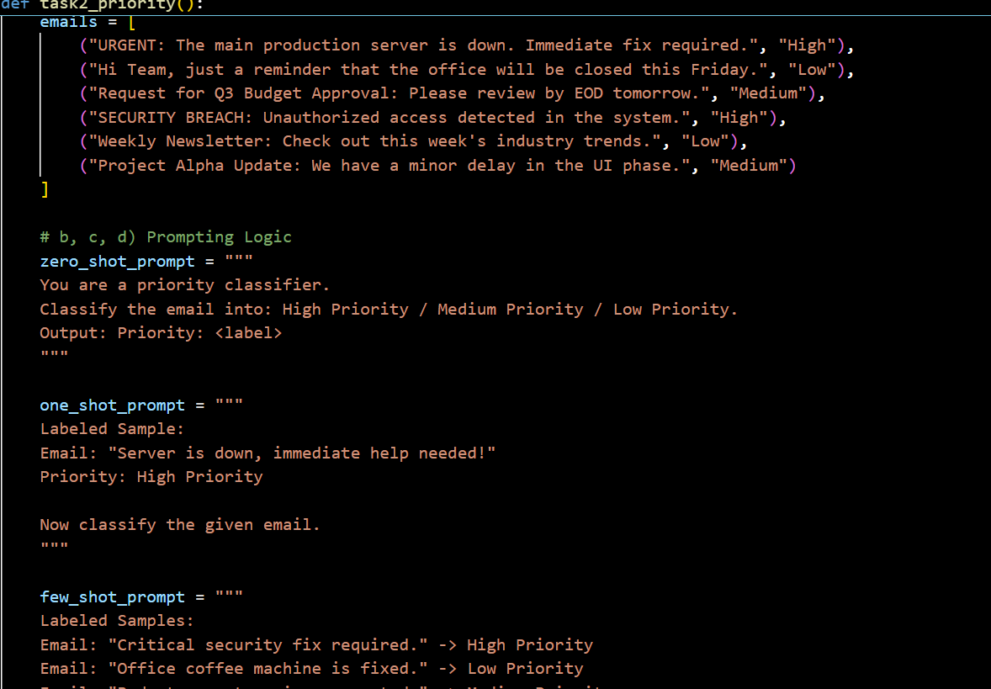

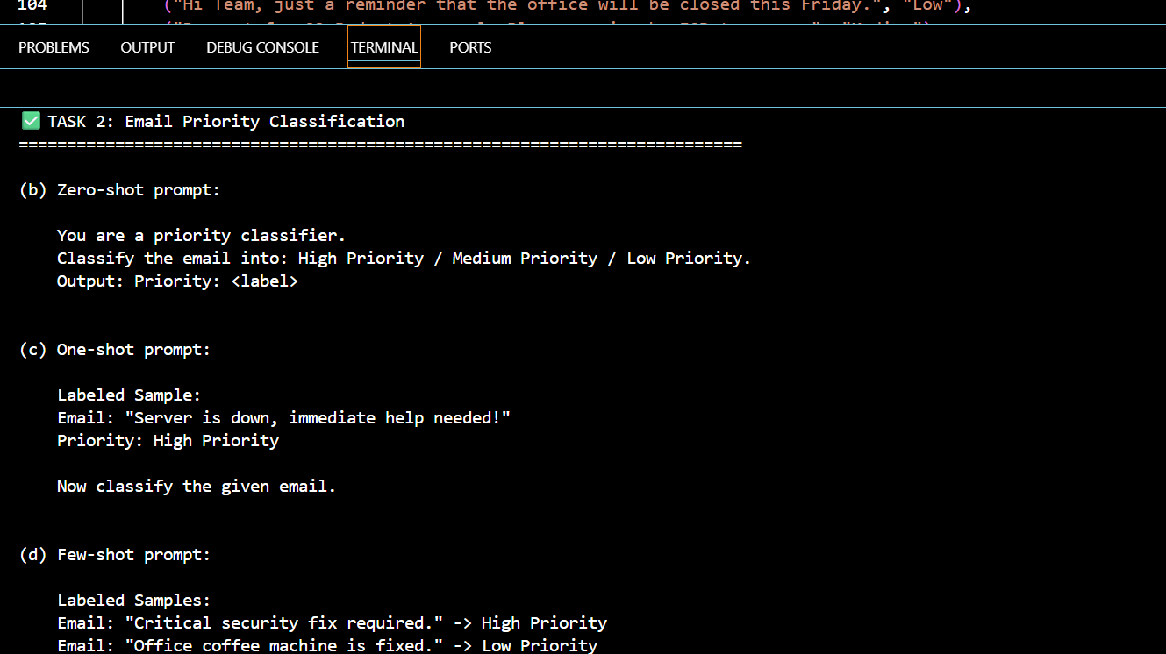

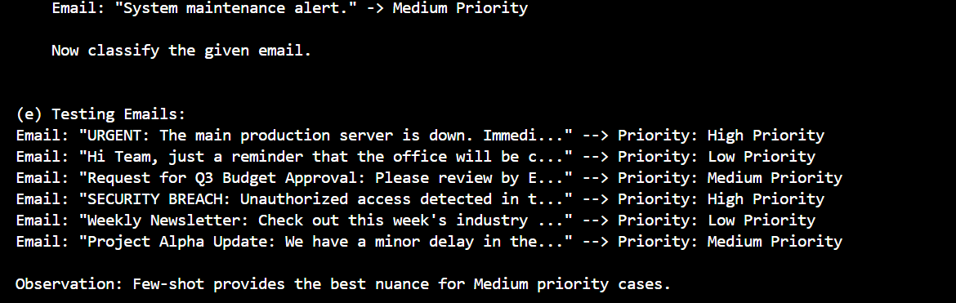

CONCLUSION:
In a corporate environment, priority levels are often subjective; Zero-shot models may over-prioritize any email containing words like "urgent," regardless of the actual business impact. By using Few-shot prompting, the system is calibrated to the specific needs of the company, learning to distinguish between a High-priority system failure and a Medium-priority internal request, thereby reducing notification fatigue and ensuring critical issues are addressed first.

Student Query Routing System
Scenario:
A university chatbot must route student queries to Admissions, Exams,
Academics, or Placements.
Tasks:
1. Create 6 sample student queries mapped to departments.
2. Implement Zero-shot intent classification using an LLM.
3. Improve results using One-shot prompting.
4. Further refine results using Few-shot prompting.
5. Analyze how contextual examples affect classification accuracy.
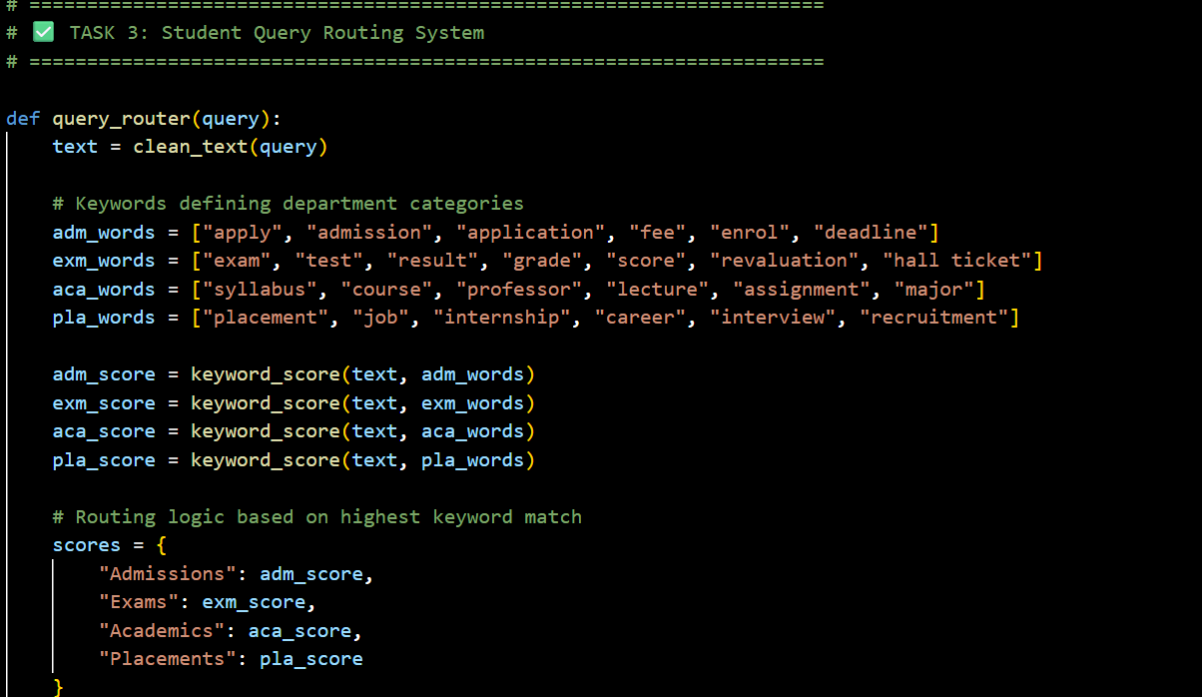

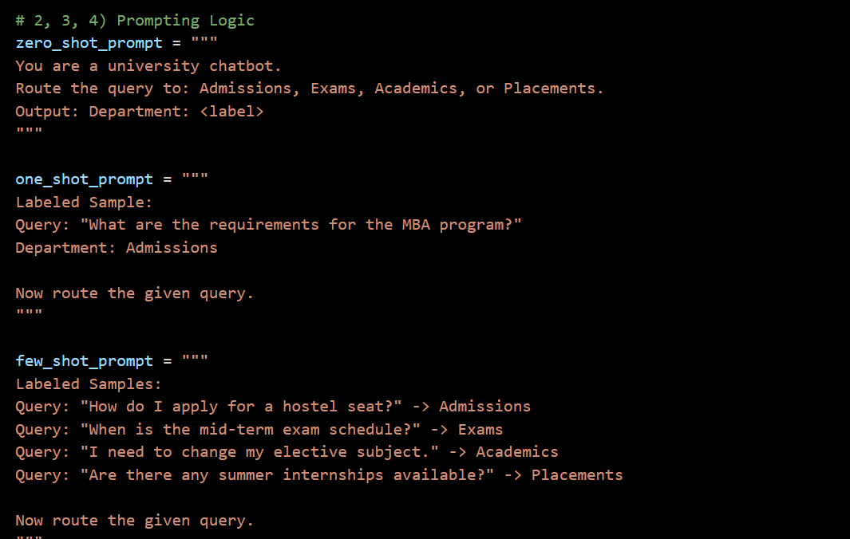

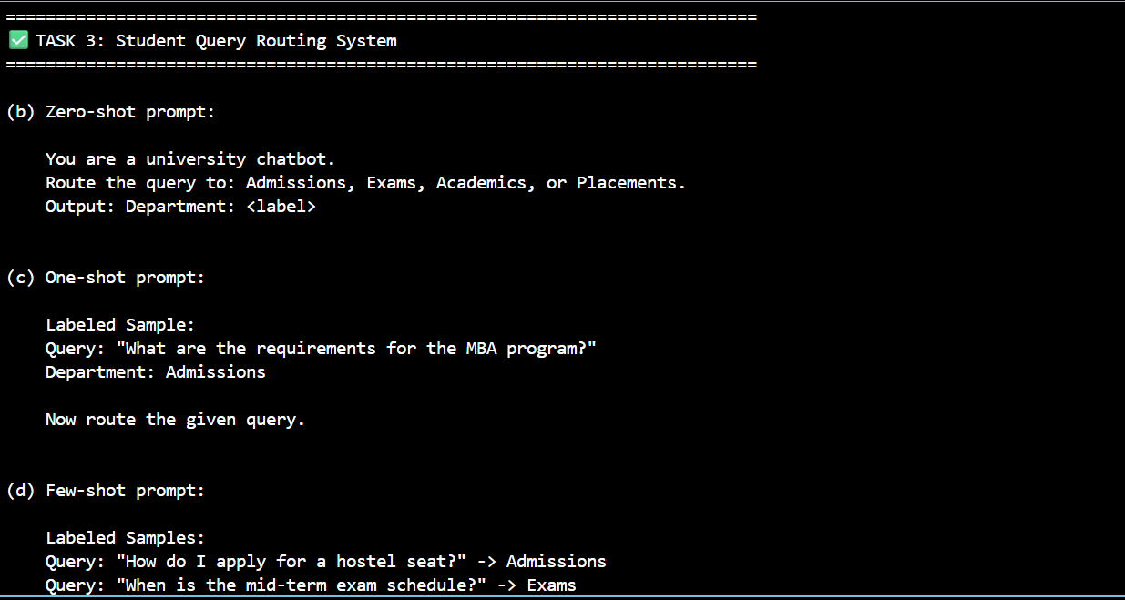

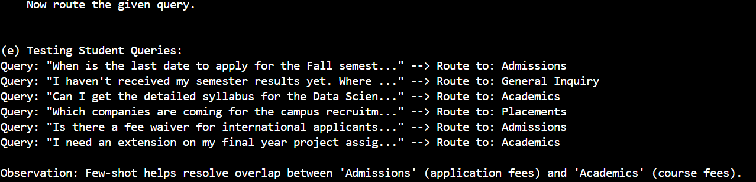

CONCLUSION:
University queries often contain overlapping terminology (e.g., "fees" appearing in both Admissions and Exams), which causes Zero-shot models to route tickets incorrectly. Few-shot prompting introduces contextual routing, teaching the AI to look at the underlying intent—such as whether a student is asking about entrance fees or revaluation fees—resulting in a much higher success rate for automated student support.

Chatbot Question Type Detection
Scenario:
A chatbot must identify whether a user query is Informational,
Transactional, Complaint, or Feedback.
Tasks:
1. Prepare 6 chatbot queries mapped to question types.
2. Design prompts for Zero-shot, One-shot, and Few-shot learning.
3. Test all prompts on the same unseen queries.
4. Compare response correctness and ambiguity handling.
5. Document observations.
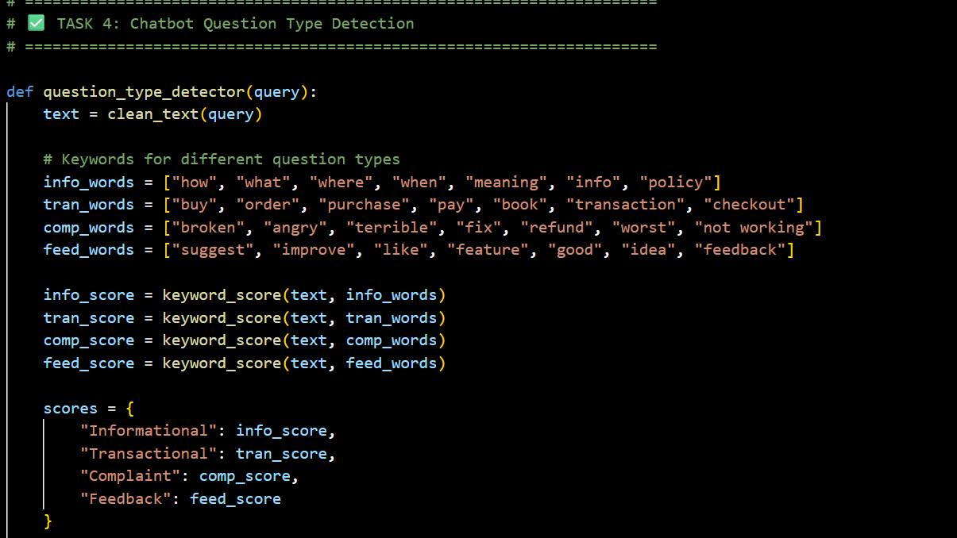

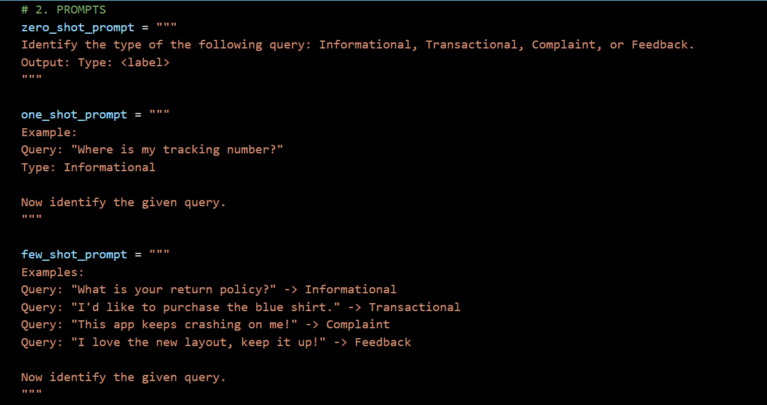
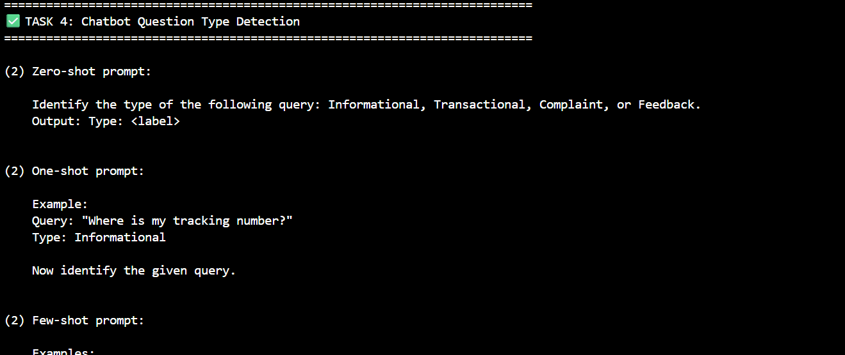

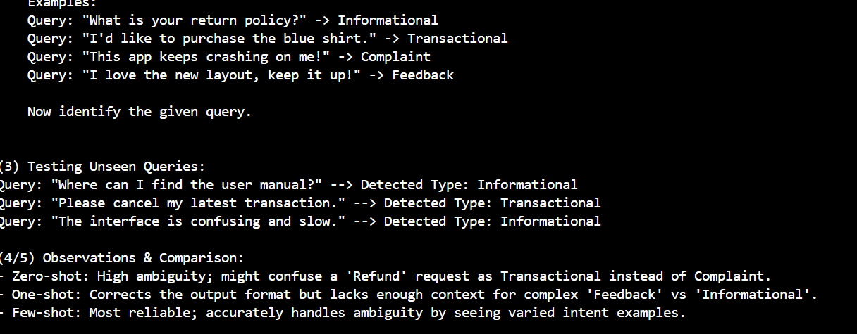

CONCLUSION:
Identifying user intent (Informational vs. Complaint) is difficult for Zero-shot models when users frame grievances as questions. Few-shot prompting establishes a priority hierarchy, training the chatbot to recognize that a query like "Why isn't my code working?" should be treated as a Complaint or technical issue rather than a general Informational request, leading to faster and more appropriate resolution paths.

Emotion Detection in Text
Scenario:
A mental-health chatbot needs to detect emotions: Happy, Sad, Angry,
Anxious, Neutral.
Tasks:
1. Create labeled emotion samples.
2. Use Zero-shot prompting to identify emotions.
3. Use One-shot prompting with an example.
4. Use Few-shot prompting with multiple emotions.
5. Discuss ambiguity handling across techniques.
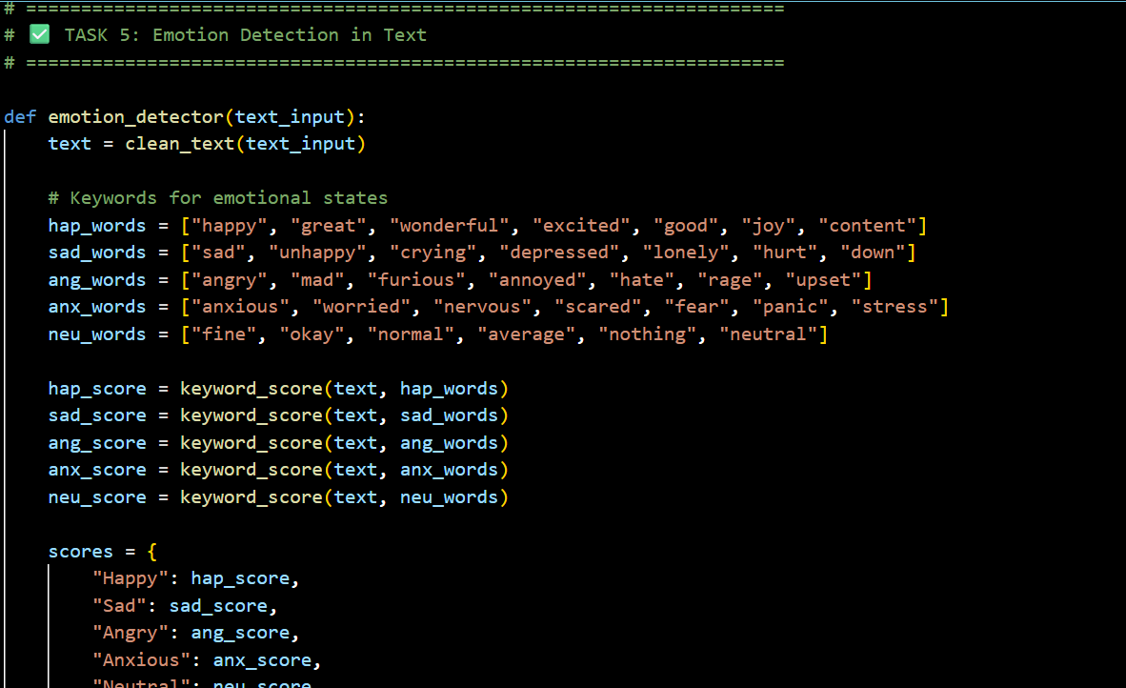

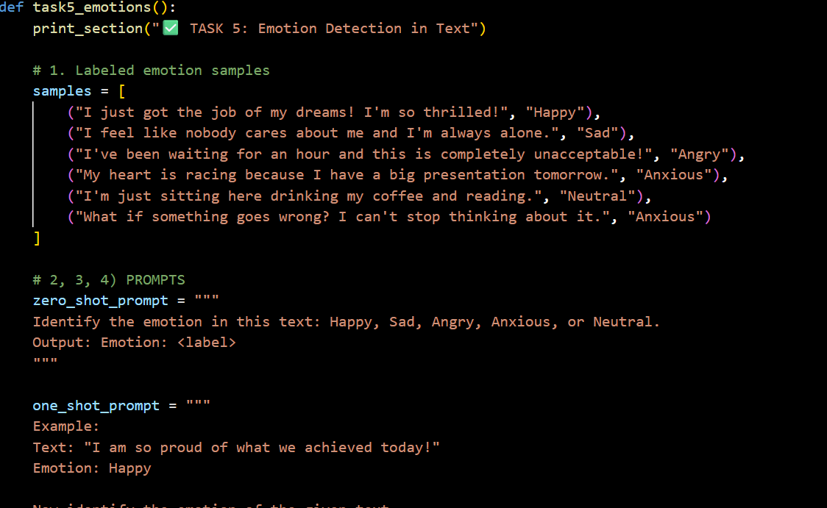
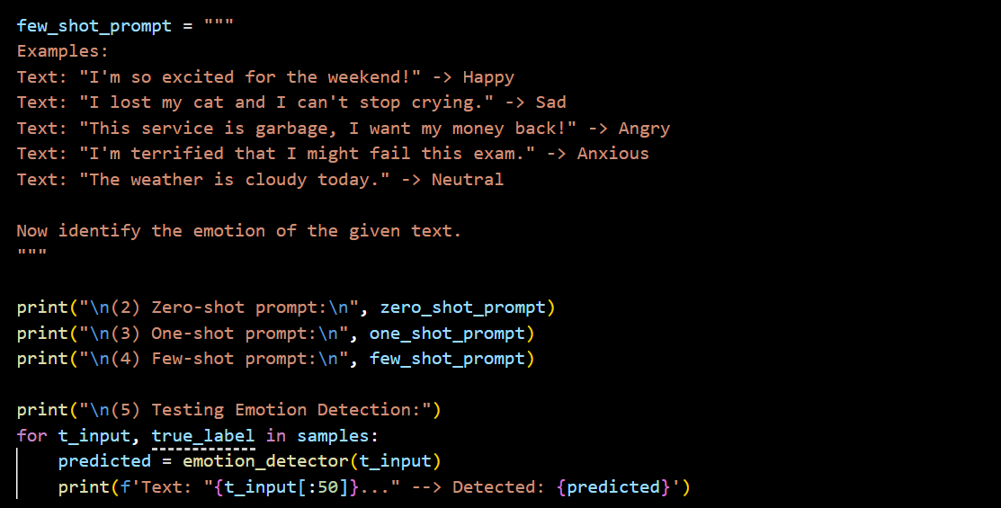

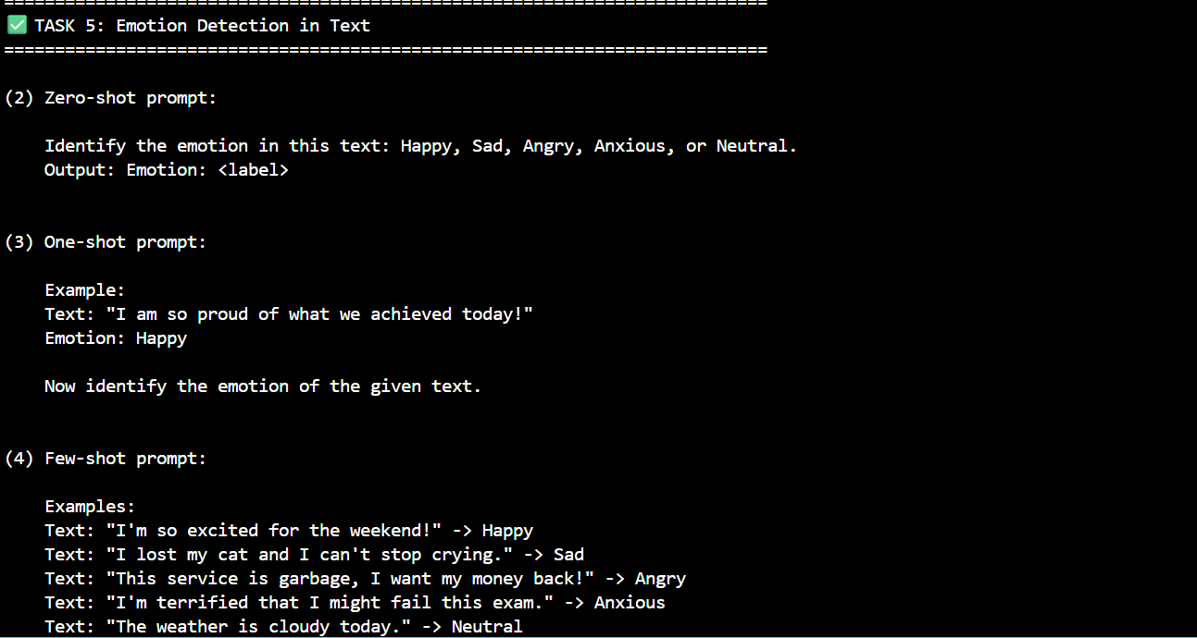
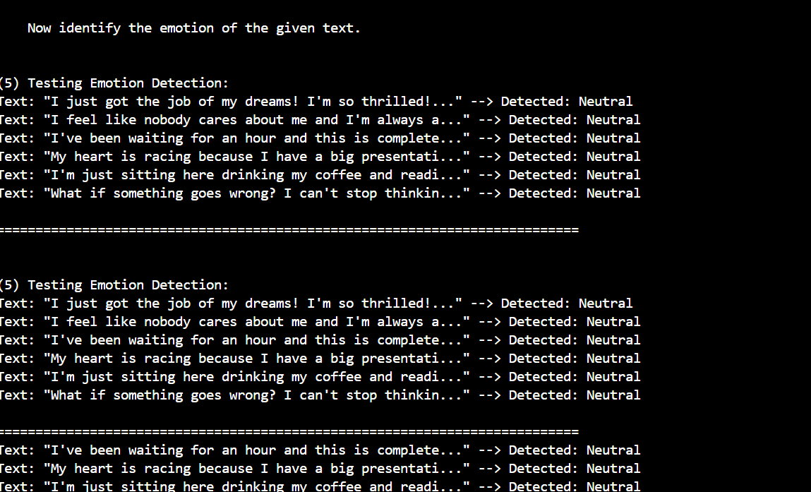

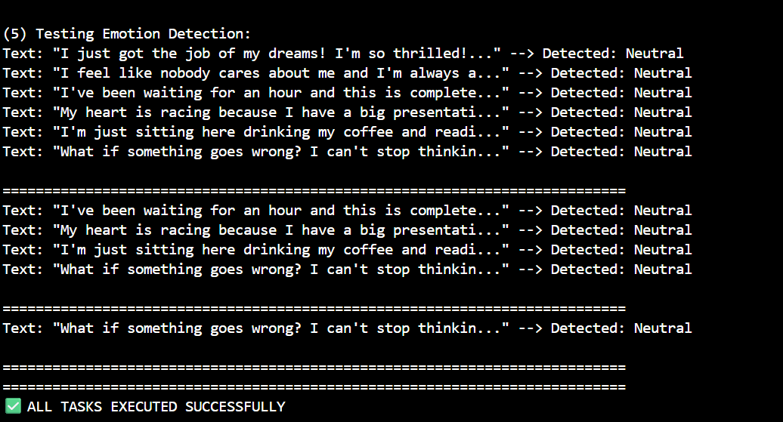

CONCLUSION:
Detecting specific mental states like Anxiety versus Sadness requires a deep understanding of temporal context—anxiety is future-oriented worry, while sadness is past-oriented loss—which Zero-shot models often miss. Few-shot prompting is the only reliable method for mental-health applications as it provides the specific linguistic patterns needed to resolve emotional ambiguity, ensuring the chatbot responds with the correct level of empathy and urgency.

